4th June 2010

Guidelines for Poster Session applicants in 2010 (tentative)

-Contents of exhibition
We call for posters that introduce the case studies, researches and technologies related EIA (Environmental Impact Assessment) including environmental policies and environmental administration. It is allowed for business to announce anonymity examples, e.g. description of business types. Also, you can attend it with profit-pursuing purpose, in this case you have to pay the fee. The summary of your exhibition, in one page of A4 size, will be published in Abstract of 9th annual Conference of Japan Society for Impact Assessment (JSIA) with abstract of oral papers.

-Period of exhibition
For two days, Saturday of 18th Sept. and Sunday of 19th Sept. 2010
You can exhibit in the afternoon of 17th Sept, and you will put away in the evening of 19th Sept in the Integrated Building of Nagoya University. http://www.nagoya-u.ac.jp/en/global-info/access-map/higashiyama/

-Method of exhibition
1) Poster making points
As a rule, please write down its title, your belongings, name of maker, or joint names person on the poster, and make the poster using graphs and pictures, as attendances easily understand it. Japanese and English will be allowed as used languages. You have to take care of the size of letters, which you can read while you stand a place 2m away. It does not matter whether you will hand attendants support documentations or pamphlets on the exhibition days.

2) Exhibition form exhibition floor
You can freely use the exhibiting space of side approx. 120cm x length approx. 260cm. The notice place for the poster will be informed later. Your poster will be fixed with cellophane adhesive tape and peeled off by your own. Please acknowledge that session secretariat cannot keep your poster in advance.

【Exhibition Place】：Presentation Space, 1st Floor of Integrated Building of Nagoya Univ.
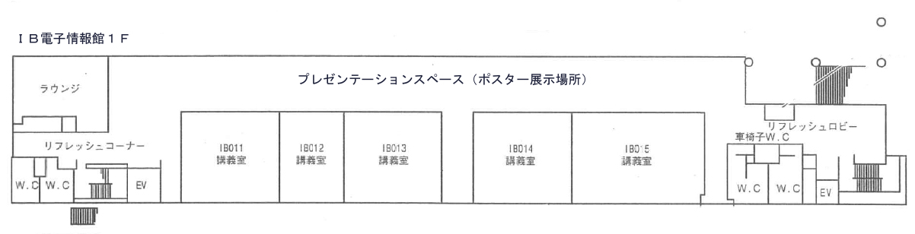
Presentation space

3) Poster Session Core Time
Poster session will be held from 11:30 to 13:00 of 18th Sept. 2010. Please necessarily stay at least one presenter during the above time.

-Exhibition fee
Exhibition fee is free. However, in the case of posters for commercial purpose, 10,000JPY is charged to presenter. Please pay the fee between Saturday of 18th Sept. and Sunday of 19th Sept. 2010.

-Application Method
1) Sending application form
Please send following “poster announcement application form” through e-mail after writing down the necessities, when you will apply to the poster session. The attendance application form should be reached by Friday of 16th July 2010.

2) Sending poster summary and session attendance application form
Please send “poster summary” by Friday of 20th Aug. through E-mail. The summary of the poster contents, in one page of A4 size, will be published in Abstract of 9th annual Conference of Japan Society for Impact Assessment (JSIA). You can download the ‘Poster Summary’ format, which is published on the Abstract, from the URL of Japan Society for Impact Assessment (http://www.jsia.net/). You could be required the revision of your poster summary.

<Application Acceptance & Inquiries >
Dr. Hideyuki Ito in charge, Prof. Hayashi Laboratory,
Rm. 531, Inter-Departmental Education and Research Facilities Building 2,
EcoTopia Science Institute, Nagoya University
Furo-cho, Chikusa-ku, Nagoya, 464-8603, Aichi pref.
TEL&FAX：052-747-6438 E-mail：jsia2010@esi.nagoya-u.ac.jp
The 9th Session of Japan Society for Impact Assessment in 2010
Poster announcement application form (Due: Friday of 16th July 2010)
This column used by Session Secretariat

Application date |  |  |  | Year |  | Month |  | Day
Applicant(s)
Belongings, title
Applicant’s  Address, tel&fax, E-mail | 〒
Applicant’s  Address, tel&fax, E-mail | TEL: |  |  |  | FAX:
Applicant’s  Address, tel&fax, E-mail | E-mail:
Poster Title
Short summary of exhibition contents
（within 150 words）
profit-pursuing activities in this session | （Yes / No）  (Put O either one) | Outline :
※Fill in the bellow in accordance with necessities
Name of exhibition group
Member type | Regular Member / Public interest member / Supporting member / Student member / Cooperation member / outside of member |  |  |  |  |  | No. of member :
Address of belongings | 〒
Address of belongings | TEL: |  | FAX:
Others
（If you can not participate Poster Session, please inform here.)
Attention : Please hesitate your cancel after the application.

-Please send this form by Friday of 16th July 2010
-Please write down the necessities, and send it to the below through e-mail by Friday of 16th July 2010. In addition, please send the poster summary by Friday of 20th Aug. 2010.

Application Acceptance & Inquiries
Dr.Hideyuki Ito in charge, Prof. Hayashi Laboratory
Rm. 531, Inter-Departmental Education and Research Facilities Building 2
EcoTopia Science Institute, Nagoya University
Furo-cho, Chikusa-ku, Nagoya, 464-8603, Aichi pref.
TEL&FAX：052-747-6438 E-mail：jsia2010@esi.nagoya-u.ac.jp

