Outlines for Making Poster Summary in 2010 (tentative)
Taro Kankyo¹, Hanako Sato¹, and Albert J. Schulder²
¹ Environmental Impact Assessment University, Japan
² Strategic Environmental Assessment Institute, Korea
Keywords: EIA, SEA, Biodiversity Offset (within 5 keywords)

1 Introduction
Text text text text text text text text text text text text text text text text text text text text text text text text text text text text text text text text text text text text text text text text text text text text text text text text text text text text text text text text text text text text text text text text text text text text text text text text text text text text text text text text text text text text text text text text text text text text text text text text text text text text text text text text text text text text text text text text text text text text text text text text text text text text text text text text text text text text text text text text text text textxt text text text text text text text text text text text text text text text text text text
2 Title
2.1 Subtitle
Text text text text text text text text text text text text text text text text text text text text text text text text text text text text text text text text text text text text ext text text text text text text text text text text text text text text text text text text text text text text text text text text text text text text text text text text text text text text text text text text text text text text text text text text text text text text text text text text text text text text text text text text text text text
2.2 Subtitle
Text text text text text text text text text text text text text text text text text text text text text text text text text text text text text text text text text text text text text text text text text text text text text text text text text text text text text text text text text text text text text text text text text text text text text text text
3 Conclusion
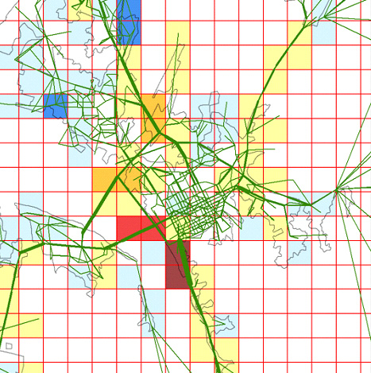
Figure 1: Text, text,
Text text text text text text text text text text text text text text text text text text text text text text text text text text text text text text text text text text text text text text text text text text text text text text text text text text text text text text text text text text text text text text text text text text text text text text text text text text text text text texttext text text text text text text text text text text text text text text text text
Table 1: Text, text, text
Text | Text | Text
45 | 55 | 65
45 | 55 | 65
45 | 55 | 65

References
Farber, S., C. R. Costanza, M. A. Wilson (2002) Economic and ecological concepts for valuing ecosystem services, Ecological Economics, No.41, pp.375-392.
WRI (World Resource Institute) (2000) Ecosystems and Human Well-being Synthesis: Synthesis, Island Press, Washington DC, 137pp.

