Template of Oral Presentation and Poster Abstract for Asia Impact Assessment Conference2018
Weihong Zhu¹, Hanako Sato², and Sang-il Hwang³
¹Yanbian University, China
²Environmental Impact Assessment University, Japan
³Korea Environment Institute, Korea
Keywords: EIA, SEA, Biodiversity Offset (with 5－7 keywords)

1. Introduction
Text text text text text text text text text text text text text text text text text text text text text text text text text text text text text text text text text text text text text text text text text text text text text text text text text text text text text text text text text text text text text text text text text text text text text text text text text text text text text text text text text text text text text text text text text text text text text text text text text text text text text text text text textxt text text text text text text text text text text text text text text text text text text
2. Title
2.1 Subtitle
Text text text text text text text text text text text text text text text text text text text text text text text text text text text text text text text text text text text text ext text text text text text text text text text text text text text text text text text text text text text text text text text text text text text text text text text
2.2 Subtitle
Text text text text text text text text text text text text text text text text text text text text text text text text text text text text text text text text text text text text text text text text text text text text text text text text text text text text text text text text text text text text text text text text text text text text text text text
3. Conclusions
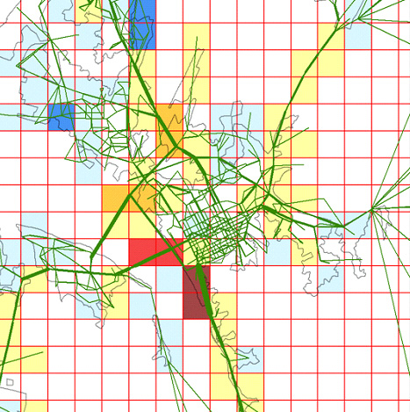
Figure 1: Text, text,
Text text text text text text text text text text text text text text text text text text text text text text text text text text text text text text text text text text text text text text text text text text text text text text text text text text text text text text text text text text text text text text text text text text text text text text text
Table 1: Text, text, text
Text | Text | Text
45 | 55 | 65
45 | 55 | 65
45 | 55 | 65

References
Farber, S., C. R. Costanza, M. A. Wilson (2002) Economic and ecological concepts for valuing ecosystem services, Ecological Economics, No.41, pp.375-392.
WRI (World Resource Institute) (2000) Ecosystems and Human Well-being Synthesis: Synthesis, Island Press, Washington DC, 137pp.

